📊 Multi-Domain Data Analysis Portfolio (5 Real-World Project

📌 Overview
This repository contains a professional multi-domain data analysis portfolio comprising five end-to-end analytics projects across Retail, Education, Weather, Healthcare, and Finance domains.
Each project demonstrates:
- Real-world data cleaning and validation
- Exploratory and advanced data analysis
- Insightful visualizations (PNG exports)
- CLI dashboards for quick insights
- Professional PDF reports with executive summaries
- Modular, reusable, OS-independent Python code
This portfolio is designed to showcase industry-ready data analysis skills suitable for academic evaluation, internships, and full-time analytics roles.

🧠 Domains Covered
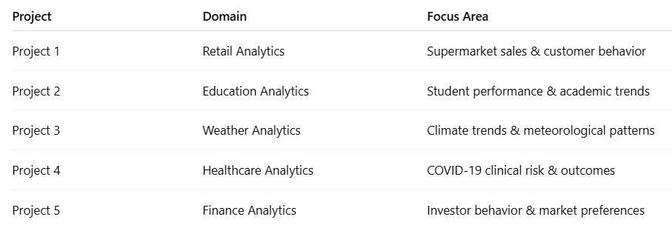

🛒 Project 1 – Retail Analytics (Supermarket Sales)
📌 Problem Statement
Retail businesses generate large volumes of transactional data, but extracting insights related to sales trends, customer behavior, and product performance is critical for improving revenue and operational efficiency.
🎯 Objectives
- Analyze daily, monthly, and hourly sales trends
- Identify top-performing product categories
- Understand customer purchase behavior
- Detect revenue and quantity mismatches
🛠️ Key Techniques Used
- Time-series aggregation
- Customer-level analysis
- Category-wise revenue analysis
- Correlation analysis between quantity and sales
📊 Sample Visualizations
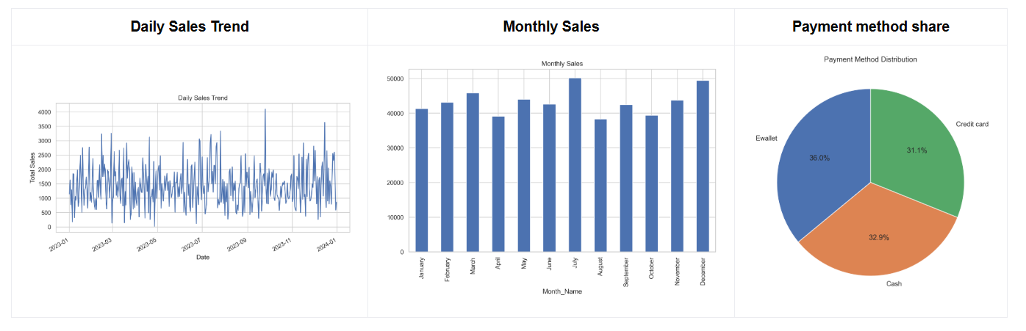
📄 PDF Report:
Supermarket Sales Analysis Report
📄 Outputs
- CLI-based sales summary dashboard
- Professional PDF report with business insights
- PNG visualizations for reporting

🎓 Project 2 – Education Analytics (Student Performance)
📌 Problem Statement
Educational institutions need data-driven insights to understand academic performance, attendance impact, and subject-wise strengths and weaknesses.
🎯 Objectives
- Analyze student pass/fail trends
- Study subject-wise performance
- Examine attendance vs academic score correlation
- Identify demographic performance patterns
🛠️ Key Techniques Used
- Descriptive statistics (mean, median)
- Correlation analysis
- Group-wise performance aggregation
- Academic outcome classification
📊 Sample Visualizations
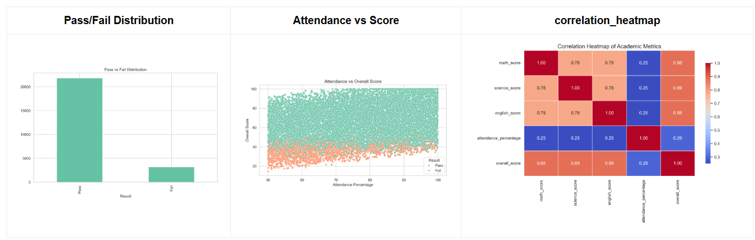
📄 PDF Report:
Student Performance Analysis Report
📄 Outputs
- Student performance CLI dashboard
- Academic insights PDF report
- Exported PNG charts for evaluation

🌦️ Project 3 – Weather Analytics (Climate Trends)
📌 Problem Statement
Raw weather data alone does not reveal climate trends or seasonal behavior. Structured analysis is required to understand long-term temperature changes and meteorological relationships.
🎯 Objectives
- Identify temperature trends over time
- Analyze seasonal and monthly patterns
- Study relationships between temperature, humidity, and wind
- Detect climate variability
🛠️ Key Techniques Used
- Time-series analysis
- Seasonal aggregation
- Correlation heatmaps
- Climate pattern visualization
📊 Sample Visualizations
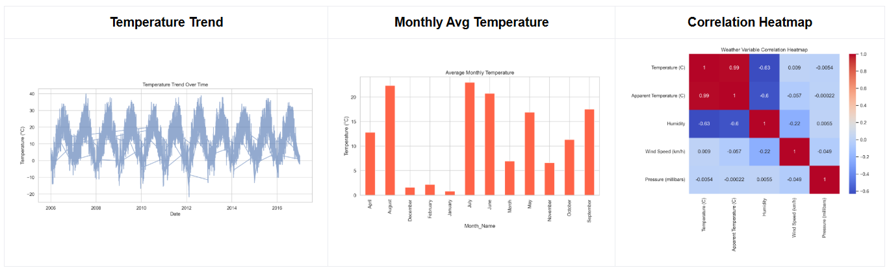
📄 PDF Report:
Weather Trends Analysis Report
📄 Outputs
- Weather trends CLI dashboard
- Climate analysis PDF report
- Publication-quality PNG visualizations

🏥 Project 4 – Healthcare Analytics (COVID-19)
📌 Problem Statement
Healthcare systems require data-driven insights to identify high-risk COVID-19 patients, understand mortality patterns, and allocate critical resources effectively.
🎯 Objectives
- Analyze COVID mortality patterns
- Study age-based risk distribution
- Evaluate impact of comorbidities
- Assess ICU admission outcomes
🛠️ Key Techniques Used
- Clinical feature engineering
- Risk stratification
- Mortality rate computation
- Healthcare correlation analysis
📊 Sample Visualizations
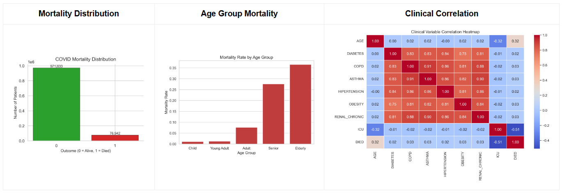
📄 PDF Report:
Healthcare COVID Analysis Report
📄 Outputs
- Healthcare CLI dashboard
- Clinical insights PDF report
- Professional healthcare-grade visualizations

💰 Project 5 – Finance & Stock Market Analytics
📌 Problem Statement
Investor behavior varies widely based on demographics, risk appetite, and financial objectives. Understanding these patterns is essential for financial advisory and product design.
🎯 Objectives
- Analyze preferred investment avenues
- Study equity market participation
- Examine risk tolerance and monitoring behavior
- Identify correlations among investment instruments
🛠️ Key Techniques Used
- Behavioral finance analysis
- Demographic segmentation
- Risk vs investment mapping
- Correlation clustering

📊 Sample Visualizations
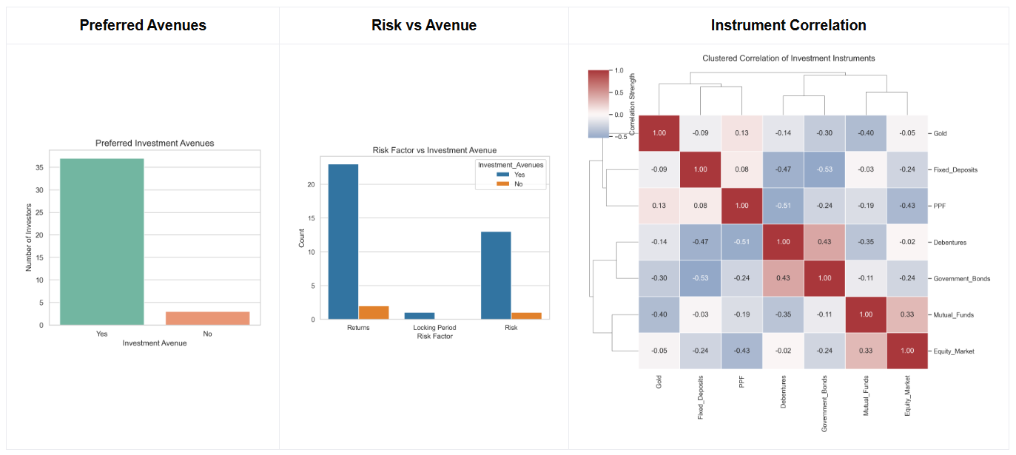
📄 PDF Report:
Finance Stock Market Analysis Report
📄 Outputs
- Advanced finance CLI dashboard
- Investor behavior PDF report
- 10+ professional finance visualizations
🛠️ Tech Stack & Tools
- Programming Language: Python
- Data Analysis: Pandas, NumPy
- Visualization: Matplotlib, Seaborn
- Notebooks: Jupyter Notebook
- CLI Dashboards: Python (argparse)
- Reports: Markdown → PDF
- Architecture: Modular Python packages
- OS Compatibility: Windows, macOS, Linux

📁 Final Project Structure
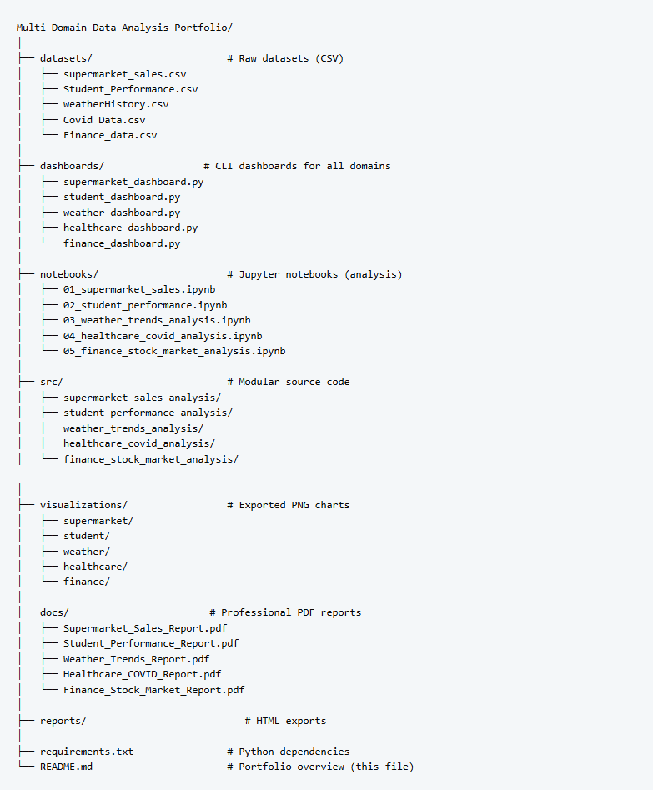

🚀 How to Set Up & Run the Projects
1️⃣ Clone the Repository
2️⃣ Create Virtual Environment (Recommended)
Activate:
- Windows
- macOS / Linux
3️⃣ Install Dependencies
📊 Running the CLI Dashboards
Each project includes a CLI dashboard for quick insights.
▶ Supermarket Sales
▶ Student Performance
▶ Weather Trends

▶ Healthcare (COVID)
▶ Finance / Stock Market
📌 All dashboards accept --data arguments if custom paths are needed.

📈 Visualizations
- All charts are exported as PNG under visualizations/
- Generated using Seaborn & Matplotlib
- Designed to be PDF-ready and publication-quality
- Color-friendly and case-safe with CSV columns

📄 PDF Reports
Each project includes a professional PDF report featuring:
- Executive summary
- Business / domain problem statement
- Methodology
- Key visualizations
- Statistical findings
- Actionable insights & recommendations
📁 Located in the reports/ directory.

🧪 Quality & Validation Standards
✔ CSV column case-safety enforced ✔ OS-independent path handling (pathlib) ✔ No hard-coded file paths ✔ Modular, reusable code ✔ Notebook ↔ CLI ↔ PDF consistency ✔ Clear separation of logic and visualization

🎯 What This Portfolio Demonstrates
- Multi-domain analytical thinking
- End-to-end project lifecycle (EDA → CLI → PDF) with Strong EDA and visualization skills
- Clean Python architecture
- Business and domain understanding
- Professional documentation and reporting
- End-to-end project ownership
- Industry-Grade Structure

👤 Author
Rahul Mahakal
Data Analytics & Python Enthusiast

📌 Final Notes
This repository represents a complete, industry-grade data analysis portfolio built with real-world structure, clarity, and professionalism. It is suitable for:
- Academic submissions
- Internships
- Data Analyst / Junior Data Scientist roles
- Portfolio reviews and interviews

